25th June 2019

**WTCR at the “Green Hell” excites the crowds**

Four drivers emerged smiling from the rest of the field in the World Touring Car Cup meeting at the Nürburgring. The series which has the Japanese premium tyre manufacturer YOKOHAMA as exclusive tyre supplier witnessed Norbert Michelisz, Johan Kristoffersson and Benjamin Leuchter succeed in claiming their first wins of the season.

The great winner of the event however was Esteban Guerrieri who collected significant points and stretched his leadership in the overall standings. With a margin of 45 points over Michelisz at the half point of the season, the Argentine will still be challenged by the field, but in a championship that has produced nine different winners in 15 races he has gained some breathing space.

After failing to claim a win in the previous events, Michelisz was finally victorious in the first race. The Hungarian made a great start from second on the grid and relaunched his chances in the title fight. “Norby’s” splendid driving meant Guerrieri focused on securing the second position. Behind the two leaders, Frédéric Vervisch, Nélson Girolami and Rob Huff delivered a thrilling fight for the last spot on the podium. At the end of lap 2, Huff benefited from the double aspiration and climbed from fifth to third. But on the third and final lap, it was his time to surrender to Girolami’s attack and lost third to the Argentine.

Reigning TCR Scandinavia champion Kristoffersson claimed a triumphant victory in the second race, which was also the first of the season for the Volkswagen Golf. It was a hot start, with Kristoffersson making contact with Antti Buri. This helped Frédéric Vervisch to pass the Finn for second. The two leaders pulled away while there was a lot of fighting behind them. Gabriele Tarquini and Rob Huff made contact at the Karussell while battling for third place and Huff retired with a broken suspension. Delayed by the incident, Tarquini lost third to Augusto Farfus and after the race he was given a 30-second time penalty that dropped him out of the points.

In Race 3, Leuchter kept his promise to shine on his home ground and scored a lights-to-flag victory starting from the pole; Guerrieri made a great start from third on the grid and challenged Leuchter for the lead during the first lap, but Vervisch took the opportunity and passed the Argentine for second, which is how they finished. During the second lap, the battle for 9th between Yvan Muller, Nicky Catsburg and Kristoffersson resulted in the Swede crashing after having been forced onto the grass by the other two cars.

The WTCR will return into action at Vila Real, Portugal on July 5/7.

Current Driver standings;

1. Girolami 215 pts

2. Michelisz 170 pts

3. Björk 161 pts

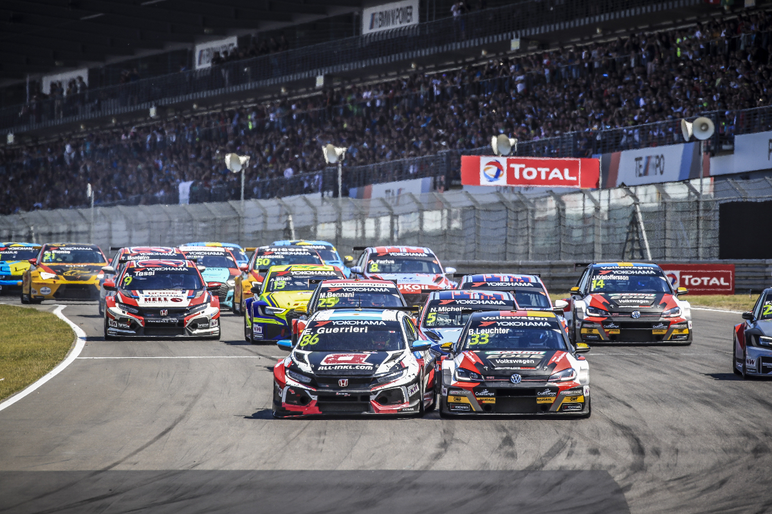

*Race 3 start Photo Gregory Lenormand*